 | 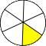 |  | 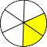
 | 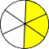 | 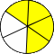 | 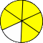
Copy and Paste Fractions
Name:
1/3
1/6
2/3
2/6
3/6
5/6
3/3
4/6

