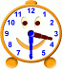
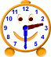
12:30
1:30
2:30
3:30
4:30
5:30
6:30
7:30
Name:

