under | on the right | on top | behind
In front | on the left | between | inside
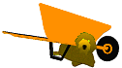
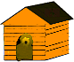
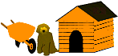
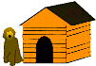
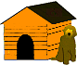
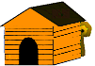
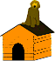
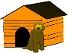
Name:

